Module 2. Working with Java data types

Primitive variables

■ char
■ byte
■ short
■ int
■ long
■ float
■ double
■ boolean

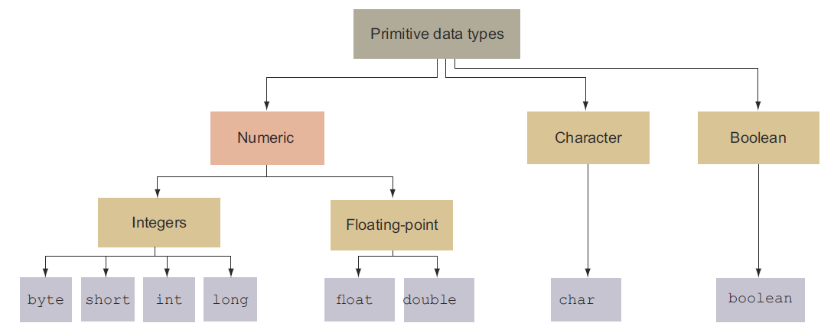

Figure. Categorization of primitive data types

Identifiers

Valid and invalid identifiers

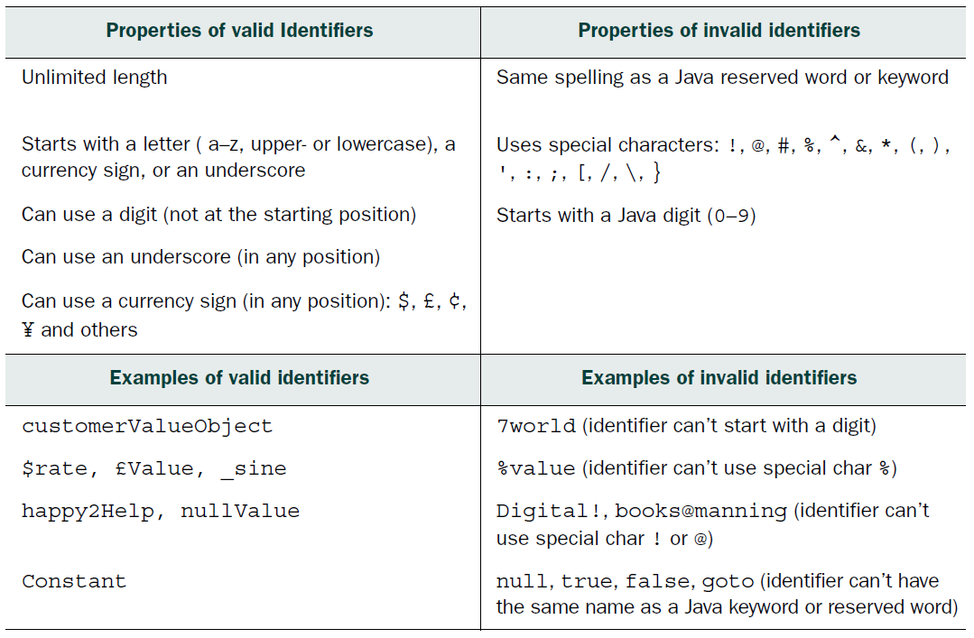

Table Ingredients of valid and invalid identifiers

What are object reference variables?

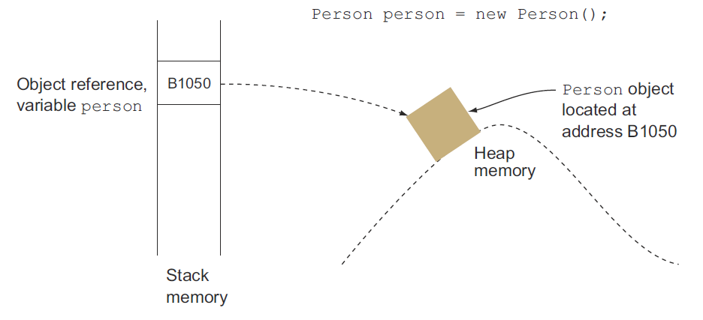

Figure. An object reference variable and the referenced object in memory

Differentiating between object reference variables and primitive variables

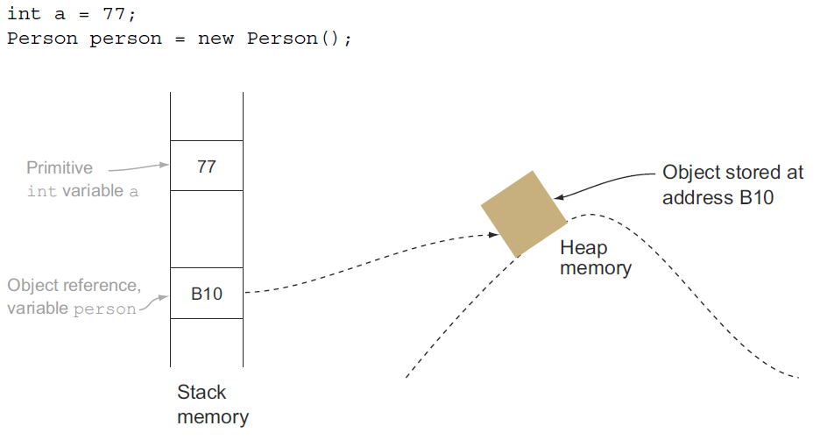

Figure. Primitive variables store the actual values, whereas object reference variables store the addresses of the objects they refer to.

Operators

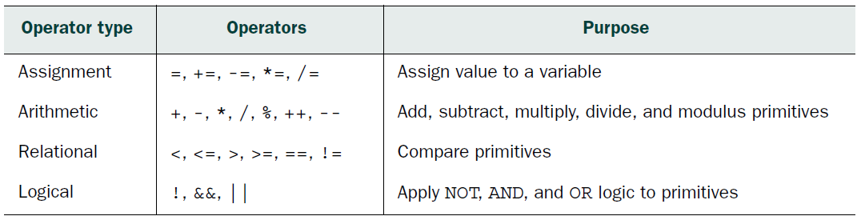

Table. Operator types and the relevant operators

Operator precedence

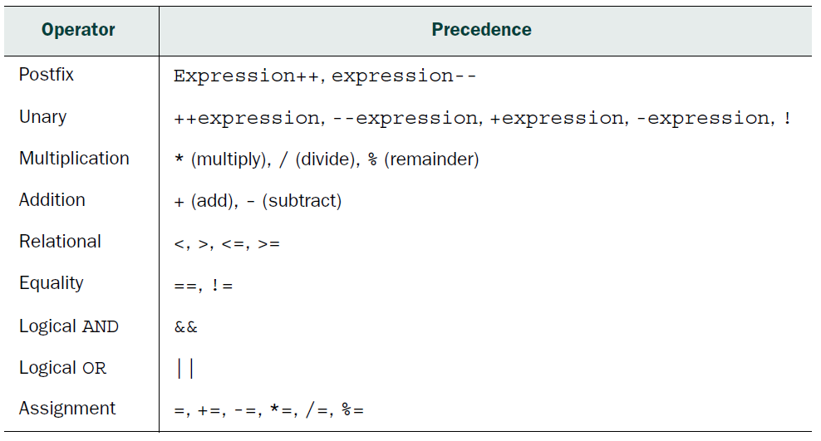

Table. Precedence of operators

Review notes

Primitive data types:
■ Java defines eight primitive data types: char, byte, short, int, long, float,
double, and boolean.
■ Primitive data types are the simplest data types.
■ Primitive data types are predefined by the programming language. A user can’t define a primitive data type in Java.
■ It’s helpful to categorize the primitive data types as Boolean, numeric, and character data types.

The Boolean data type:
■ The boolean data type is used to store data with only two possible values. These two possible values may be thought of as yes/no, 0/1, true/false, or any other combination. The actual values that a boolean can store are true and false.
■ true and false are literal values.
■ A literal is a fixed value that doesn’t need further calculations to be assigned to any variable.

Numeric data types:
■ Numeric values can be stored either as integers or decimal numbers.
■ byte, short, int, and long can be used to store integers.
■ The byte, short, int, and long data types use 8, 16, 32, and 64 bits, respectively, to store their values.
■ float and double can be used to store decimal numbers.
■ The float and double data types use 32 and 64 bits, respectively, to store
their values.
■ The default type of integers—that is, nondecimal numbers—is int.
■ To designate an integer literal value as a long value, add the suffix L or l to the literal value.

■ Numeric values can be stored in binary, octal, decimal, and hexadecimal number formats.
■ Literal values in the decimal number system use digits from 0 to 9 (a total of 10 digits).
■ Literal values in the octal number system use digits from 0 to 7 (a total of
8 digits).
■ Literal values in the hexadecimal number system use digits from 0 to 9 and letters from A to F (a total of 16 digits and letters).
■ Literal values in the binary number system use digits 0 and 1 (a total of 2 digits).
■ The literal values in the octal number system start with the prefix 0. For example, 0413 in the octal number system is 267 in the decimal number system.
■ The literal values in the hexadecimal number system start with the prefix 0x. For example, 0x10B in the hexadecimal number system is 267 in the decimal number system.
■ The literal values in the binary number system start with the prefix 0b or 0B. For example, the decimal value 267 is 0B100001011 in the binary system.
■ You can use underscores within the Java literal values to make them more readable. 0B1_0000_10_11, 0_413, and 0x10_B are valid
binary, octal, and hexadecimal literal values.
■ The default type of a decimal number is double.
■ To designate a decimal literal value as a float value, add the suffix F or f to the literal value.
■ The suffixes D and d can be used to mark a literal value as a double value.
Though it’s allowed, doing so is not required because the default value of decimal literals is double.

Character primitive data types:
■ A char data type can store a single 16-bit Unicode character; that is, it can store characters from virtually all the world’s existing scripts and languages.
■ You can use values from \u0000 (or 0) to a maximum of \uffff (or 65,535
inclusive) to store a char. Unicode values are defined in the hexadecimal number system.
■ Internally, the char data type is stored as an unsigned integer value (only positive integers).
■ When you assign a letter to a char, Java stores its integer equivalent value. You may assign a positive integer value to a char instead of a letter, such as 122.
■ The literal value 122 is not the same as the Unicode value \u0122. The former is a decimal number and the latter is a hexadecimal number.
■ Single quotes, not double quotes, are used to assign a letter to a char variable.

Valid identifiers:
■ A valid identifier starts with a letter (a–z, upper- or lowercase), a currency sign, or an underscore. There is no limit to its length.
■ A valid identifier can contain digits, but not in the starting place.
■ A valid identifier can use the underscore and currency sign at any position of the identifier.
■ A valid identifier can’t have the same spelling as a Java keyword, such as switch.
■ A valid identifier can’t use any special characters, including !, @, #, %, ^, &, *, (,), ', :, ;, [, /, \, or }

Assignment operators:
■ Assignment operators can be used to assign or reassign values to all types of variables.
■ A variable can’t be assigned to an incompatible value. For example, character and numeric values cannot be assigned to a boolean variable, and vice versa.
■ += and -= are short forms of addition/subtraction and assignment.
■ += can be read as “first add and then assign” and -= can be read as “first subtract and then assign.”

Arithmetic operators:
■ Arithmetic operators can’t be used with the boolean data type. Attempting to do so will make the code fail to compile.
■ ++ and –- are unary increment and decrement operators. These operators work with single operands.
■ Unary operators can be used in prefix or postfix notation.
■ When the unary operators ++ and -- are used in prefix notation, the value of the variable increments/decrements just before the variable is used in an expression.
■ When the unary operators ++ and -- are used in postfix notation, the value of the variable increments/decrements just after the variable is used in an expression.
■ By default, unary operators have a higher precedence than multiplication operators and addition operators.

Relational operators:
■ Relational operators are used to compare values for equality (==) and nonequality (!=). They are also used to determine whether two numeric values are greater than (>, >=) or less than (<, <=) each other.
■ You can’t compare incomparable values. For example, you can’t compare a boolean with an int, a char, or a floating-point number. If you try to do so,
your code will not compile.
■ The operators equal to (==) and not equal to (!=) can be used to compare all types of primitives: char, byte, short, int, long, float, double, and boolean.
■ The operator == returns true if the primitive values being compared are equal.
■ The operator != returns true if the primitive values being compared are not equal.
■ The result of the relational operator is always a boolean value.

Logical operators:
■ You can use the logical operators to determine whether a set of conditions is true or false and proceed accordingly.
■ Logical AND (&&) evaluates to true if all operands are true, and false otherwise.
■ Logical OR (||) evaluates to true if any or all of the operands is true.
■ Logical negation (!) negates the boolean value. It evaluates to true for false, and vice versa.
■ The result of a logical operation is always a boolean value.
■ The logical operators && and || are also called short-circuit operators. If these operators can determine the output of the expression with the evaluation of the
first operand, they don’t evaluate the second operand.
■ The && operator returns true only if both of the operands are true. If the first operand to this operator evaluates to false, the result can never be true. Therefore, && does not evaluate the second operand.
■ Similarly, the || operator returns true if any of the operands is true. If the first operand to this operator evaluates to true, the result can never be false. Therefore, || does not evaluate the second operator.

Sample questions

Q2-1. Select all incorrect statements:
a A programmer can’t define a new primitive data type.
b A programmer can define a new primitive data type.
c Once assigned, the value of a primitive can’t be modified.
d A value can’t be assigned to a primitive variable.

Q2-2. Which of the options are correct for the following code?
public class Prim { // line 1
public static void main(String[] args) { // line 2
char a = 'a'; // line 3
char b = -10; // line 4
char c = '1'; // line 5
integer d = 1000; // line 6
System.out.println(++a + b++ * c - d); // line 7
} // line 8
} // line 9
a Code at line 4 fails to compile.
b Code at line 5 fails to compile.
c Code at line 6 fails to compile.
d Code at line 7 fails to compile.

Q2-3. What is the output of the following code?
public class Foo {
public static void main(String[] args) {
int a = 10;
long b = 20;
short c = 30;
System.out.println(++a + b++ * c);
}
}
a 611
b 641
c 930
d 960

Q2-4. Select the option(s) that is/are the best choice for the following:
___________________ should be used to store a count of cars manufactured by a car
manufacturing company. _________________ should be used to store whether this
car manufacturing company modifies the interiors on the customer’s request.
____________ should be used to store the maximum speed of a car.
a long, boolean, double
b long, int, float
c char, int, double
d long, boolean, float

Q2-5. Which of the following options contain correct code to declare and initialize variables to store whole numbers?
a bit a = 0;
b integer a2 = 7;
c long a3 = 0x10C;
d short a4 = 0512;
e double a5 = 10;
f byte a7 = -0;
g long a8 = 123456789;

Q2-6. Select the options that, when inserted at // INSERT CODE HERE, will make the following code output a value of 11:
public class IncrementNum {
public static void main(String[] args) {
int ctr = 50;
// INSERT CODE HERE
System.out.println(ctr % 20);
}
}

a ctr += 1;
b ctr =+ 1;
c ++ctr;
d ctr = 1;

Q2-7. What is the output of the following code?
int a = 10;
int b = 20;
int c = (a * (b + 2)) - 10-4 * ((2*2) - 6;
System.out.println(c);
a 218
b 232
c 246
d Compilation error

Q2-8. What is true about the following lines of code?
boolean b = false;
int i = 90;
System.out.println(i >= b);
a Code prints true
b Code prints false
c Code prints 90 >= false
d Compilation error

Q2-9. Examine the following code and select the correct options:
public class Prim { // line 1
public static void main(String[] args) { // line 2
int num1 = 12; // line 3
float num2 = 17.8f; // line 4
boolean eJavaResult = true; // line 5
boolean returnVal = num1 >= 12 && num2 < 4.567 // line 6
|| eJavaResult == true;
System.out.println(returnVal); // line 7
} // line 8
} // line 9
a Code prints false
b Code prints true
c Code will print true if code on line 6 is modified to the following:
boolean returnVal = (num1 >= 12 && num2 < 4.567) || eJavaResult ==
true;
d Code will print true if code on line 6 is modified to the following:
boolean returnVal = num1 >= 12 && (num2 < 4.567 || eJavaResult ==
false);

Q2-10. If the functionality of the operators = and > were to be swapped in Java (for the code on line numbers 4, 5, and 6), what would be the result of the following code?
boolean myBool = false; // line 1
int yourInt = 10; // line 2
float hisFloat = 19.54f; // line 3
System.out.println(hisFloat > yourInt); // line 4
System.out.println(yourInt = 10); // line 5
System.out.println(myBool > false); // line 6
a true
true
false
b 10.0
false
false
c false
false
false
d Compilation error

